Purpose of the CRUD Python Module:
The goal of this project was to create a Python module that allows Grazioso Salvare to work directly with animal shelter data stored in MongoDB. The module provides a simple way for other Python programs to add, retrieve, update, and remove animal records without needing to directly write MongoDB commands each time.
This work focuses on the database portion of the application. It creates a foundation that can later be connected to a client-facing dashboard in Project Two.

How the Module Is Used:
The CRUD functionality is written as a Python class that can be imported into other scripts or Jupyter Notebooks. When the class is instantiated, it establishes an authenticated connection to the MongoDB database. Once connected, the methods provided can be called to perform database operations.
This approach keeps the database logic in one place, which makes the code easier to reuse and maintain as the project expands.

Python Driver Used:
The MongoDB driver used for this project is PyMongo. PyMongo was selected because it is the official Python driver for MongoDB and provides direct access to MongoDB’s built-in features. It is widely used, well supported, and works naturally with Python’s object-oriented structure, which made it a good fit for this project.

CRUD Operations:
The module supports the four standard CRUD operations used in database applications:
Create
The Create method inserts a new document into the MongoDB collection. It accepts a dictionary containing animal data and returns True when the insert is successful.
Read
The Read method searches the collection using a query dictionary and returns the results as a list. The method uses MongoDB’s find() function so that multiple matching records can be returned when applicable.
Update
The Update method modifies existing documents that match a given query. Only the specified fields are updated, and the method returns the number of records that were changed.
Delete
The Delete method removes documents from the collection based on a query and returns the number of records that were deleted.
Each method includes basic error handling and follows standard Python naming and formatting practices.

Demonstration of Functionality:
All CRUD operations were tested using a separate Jupyter Notebook file (ProjectOneTestScript.ipynb). The notebook imports the CRUD module, connects to MongoDB using an authenticated user account, and runs each operation against the database.
MongoDB Import
The Austin Animal Center Outcomes dataset was imported into MongoDB using the mongoimport command.
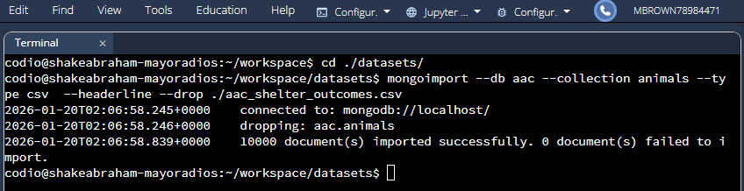

User Authentication
A dedicated MongoDB user account was created and used to log into the database through the mongo shell.
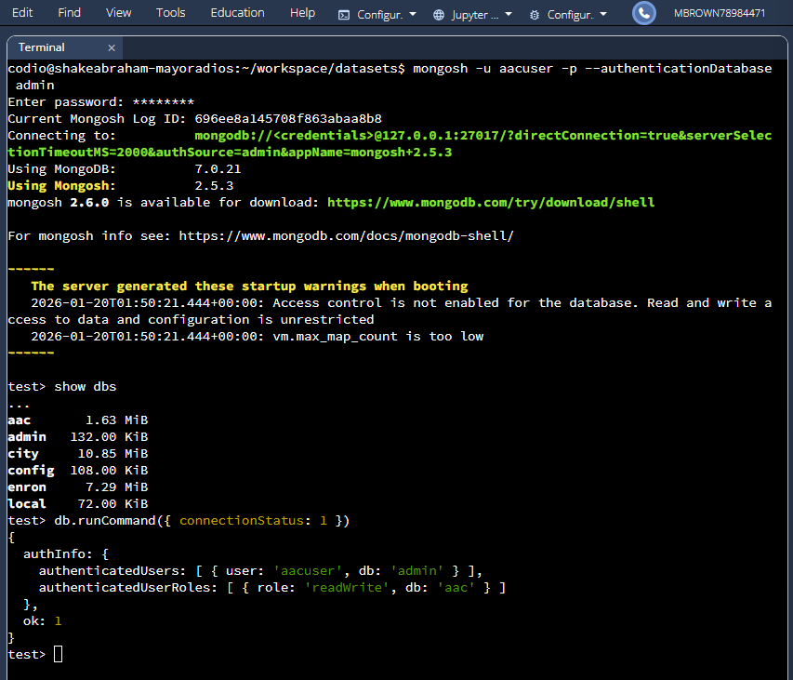

CRUD Testing
The Jupyter Notebook demonstrates inserting a test record, retrieving it, updating one of its fields, and then deleting the record from the database.
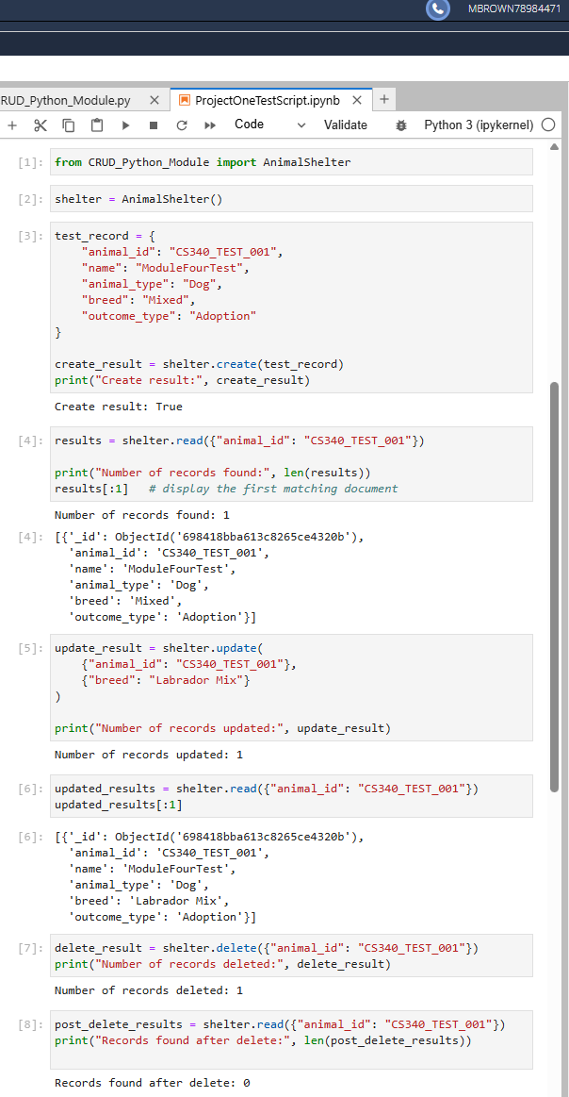
Conclusion:
This project results in a working MongoDB database and a reusable Python CRUD module that meets the needs of the Grazioso Salvare scenario. The module provides a clean and secure way to interact with animal shelter data and sets the groundwork for further development in the next phase of the project.

